Homework - Day 40

Mount ADLS Gen2 in databricks.

- Open Microsoft Entra ID and go to App registration.
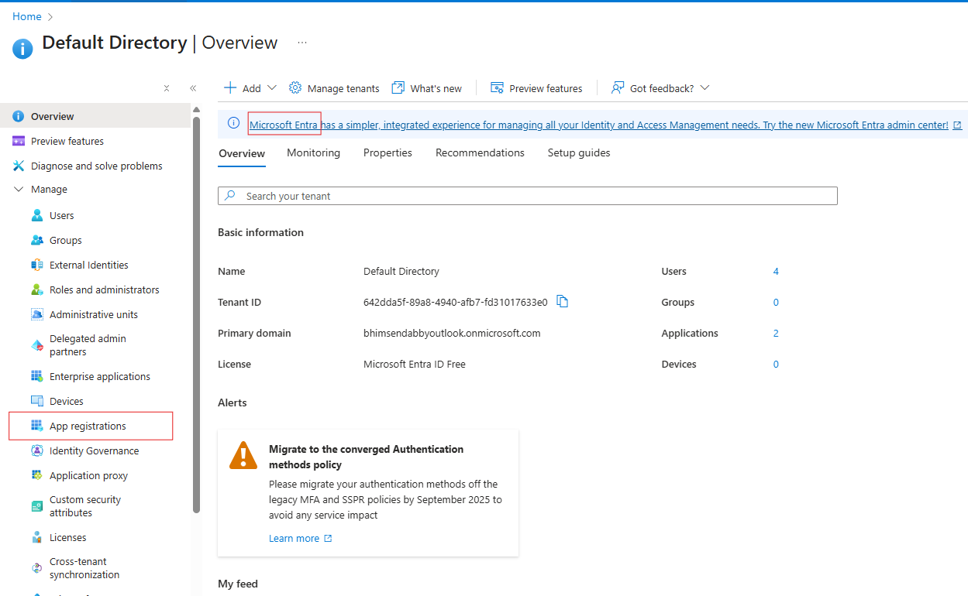
- Add New Registration and select single tenant option.
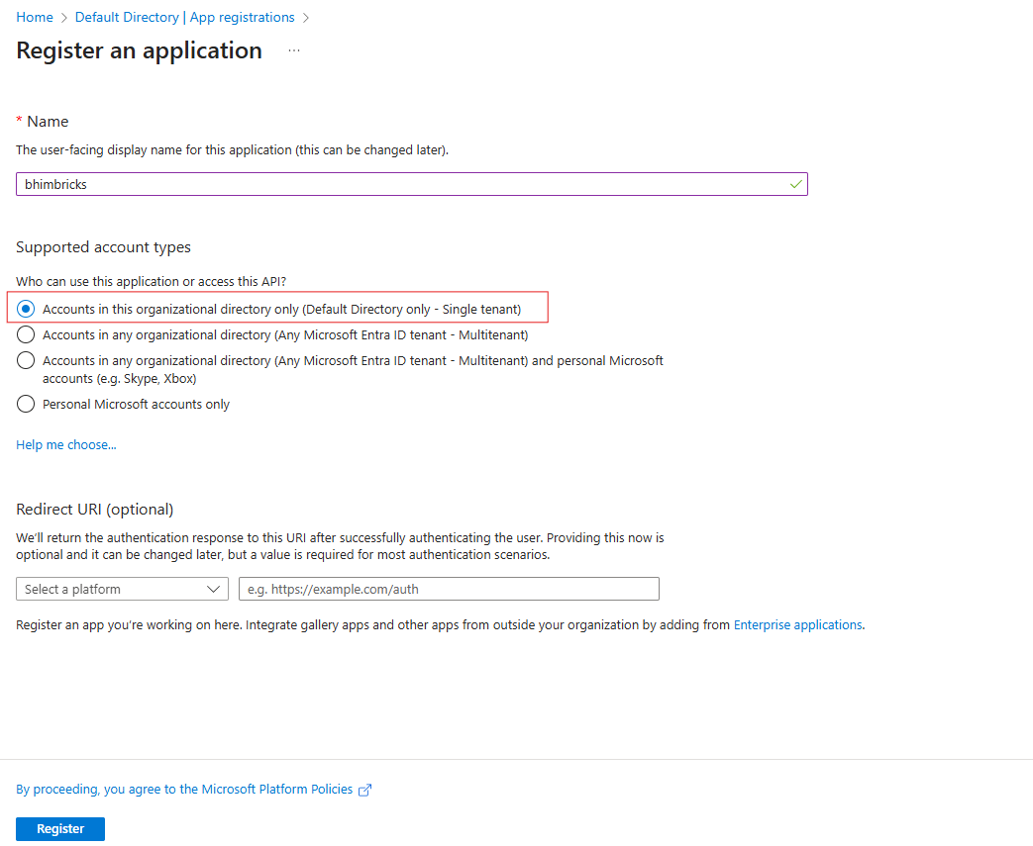
- Copy service principle name, app Id and tenant id.
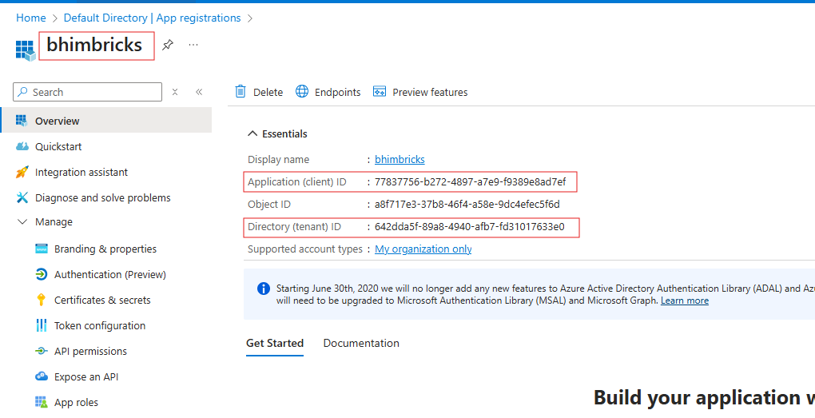
- Go to certificate and secrets and create secret Id and give any name.
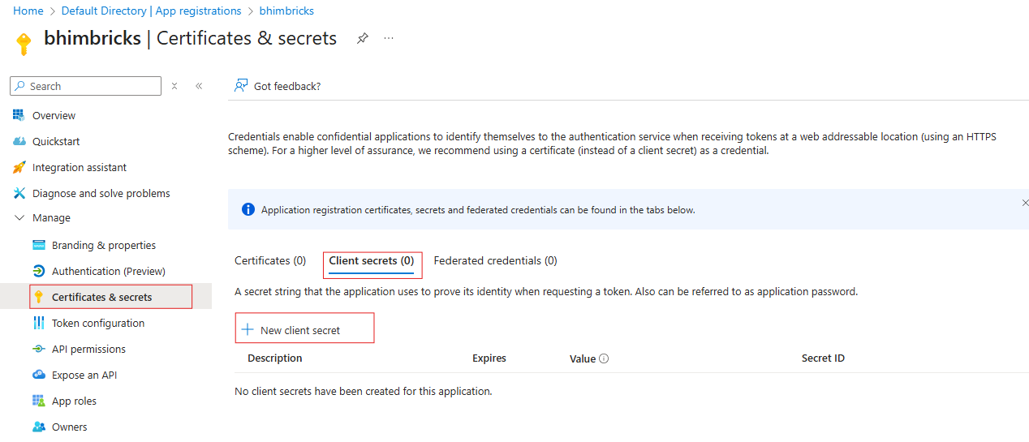
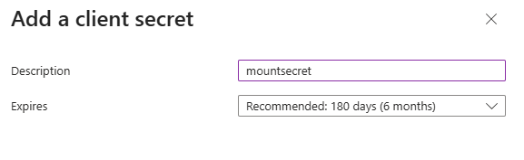
- Now copy the value of this secret Id. 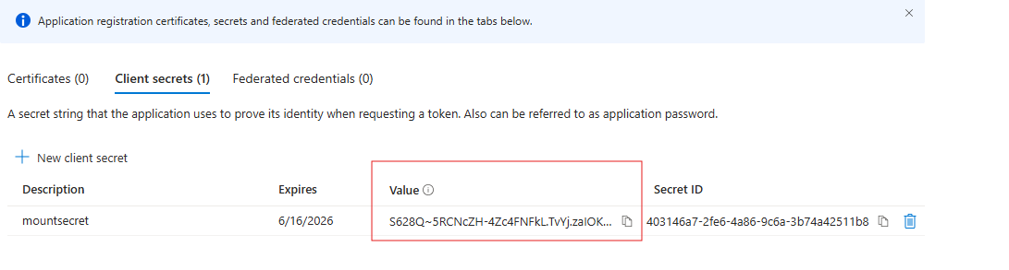
- Now we need to store this secret Id in key vault and we will access this key in databricks using key vault. Create new key vault resource using vault access policy.
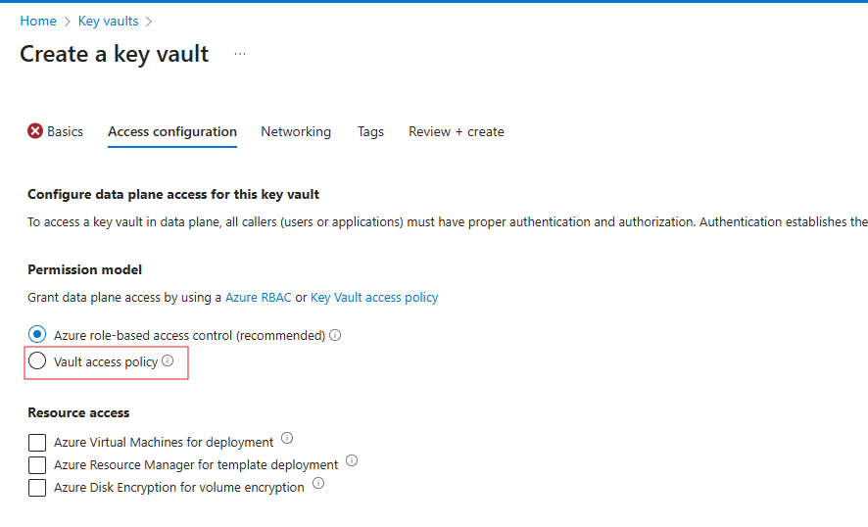
- Now go to the secrets section of created key vault and click on the generate/ import.
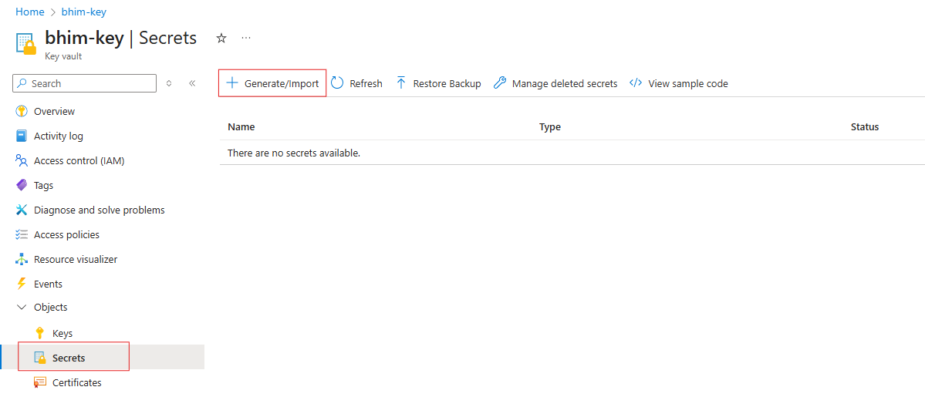
- Now copy and paste the value of secret Id which we generated at step 5. We need to do this task for app id and tenant id also for step 3.
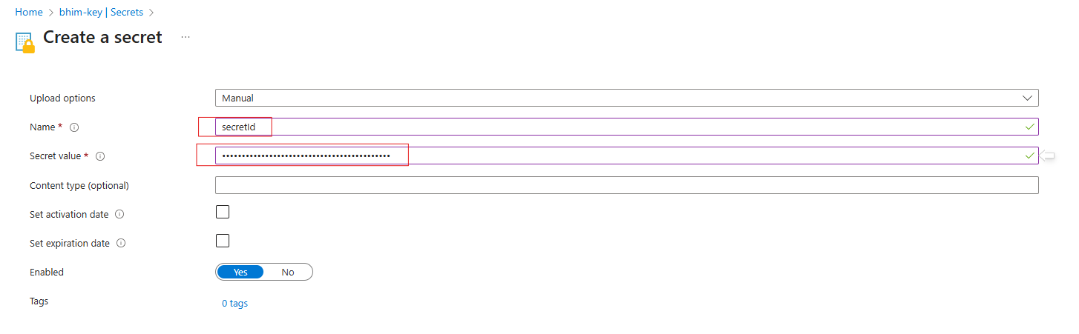
- We need permission on AdLGen2 for performing operation so we are adding a role of storage blob data contributor for service principle. Go to ADLGen2 storage account -> Access Control IAM -> Add role assignment.
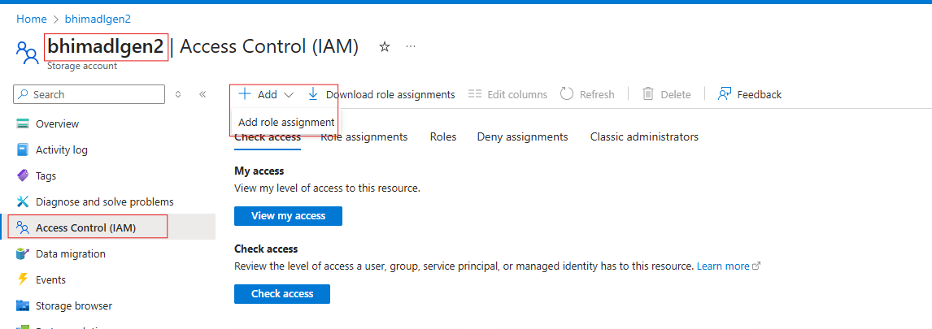

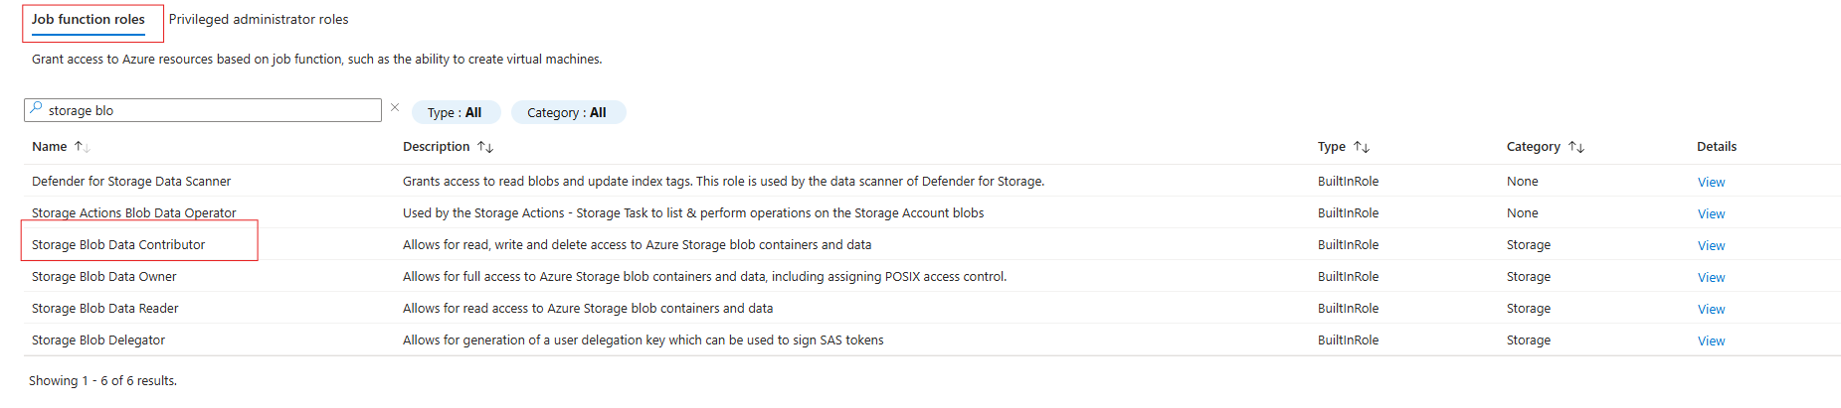
- Now select the service principle name.
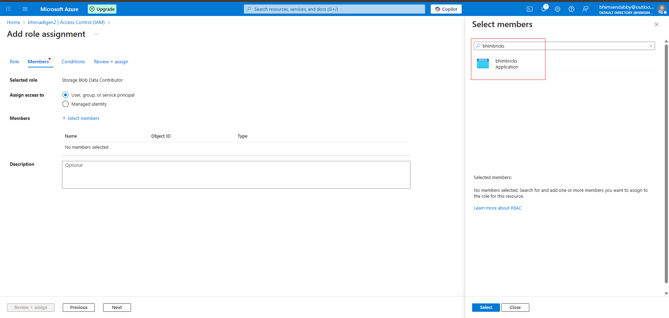

- Next step is to make connection between key vault and databricks. Go To databricks workspace and remove the red part from the url in thw browser and paste this - #secrets/createScope

- Go to key vault -> Properties. Copy the vault URI and resource ID and paste these in DNS URL and resource ID. Give the name to the Scope – I gave adlgen2.
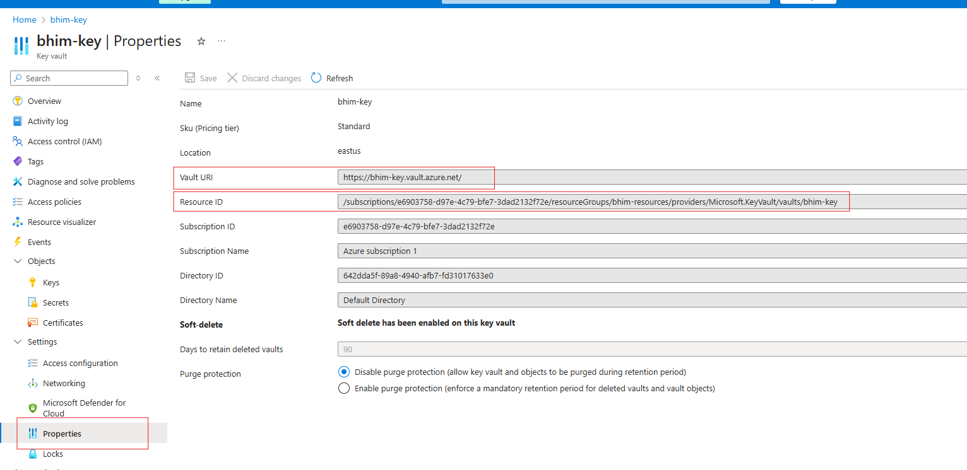

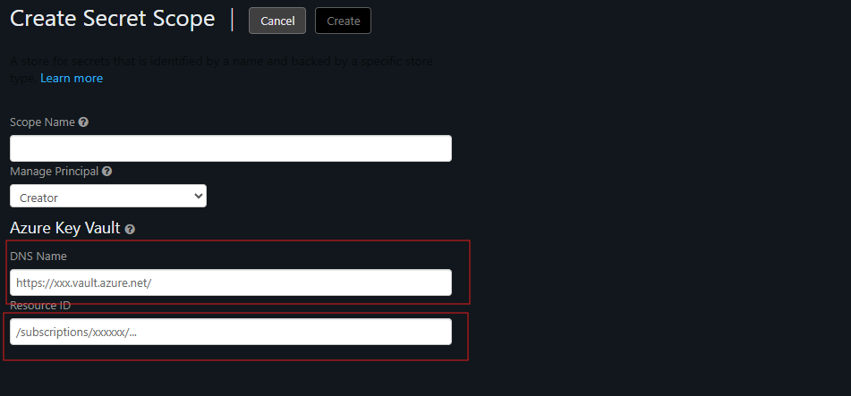

- Go to databricks and create a notebook. Run these commands.
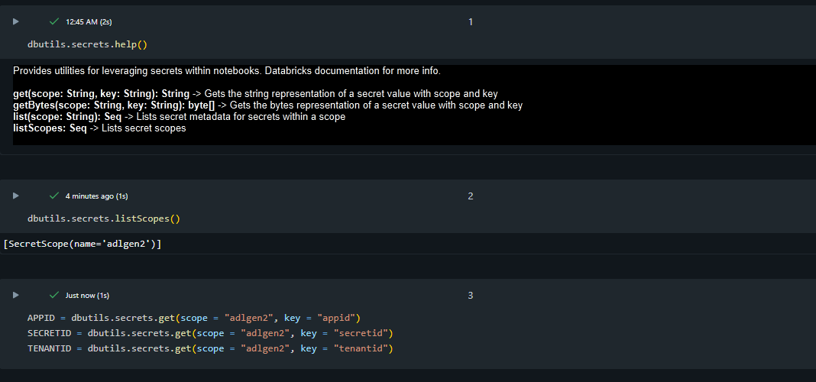

- Go to this URL - https://learn.microsoft.com/en-us/azure/databricks/dbfs/mounts
Copy paste the code from the above URL and paste the for app-id, tenant-id, secret-id, adlgen2 storage account name, container name.

